OTL-NRCAN P.4.1 EFFICIENCY PROGRAM

SCOPE
Canada’s Energy Efficiency Act and Energy Efficiency Regulations are administered by Natural Resources Canada (NRCan). Regulated energy-using products imported into Canada or shipped between provinces or territories must bear an energy efficiency verification mark from a certification body accredited for energy efficiency verification/certification by the Standards Council of Canada. Many OTL clients produce heating appliances that are required to be regulated by NRCan for their energy efficiency.

This program details how OTL conforms to NRCan requirements, including other regulatory groups, and provides clients a method of being approved to sell products destined for the Canadian market required to be verified for energy efficiency using the following standard: “Testing method for Measuring Annual Fireplace Efficiencies, CSA P.4.1”.

SAFETY TESTING & CERTIFICATION
Often OTL does not specifically provide exclusive conformance to energy efficiency requirements. OTL performs safety testing, evaluation, and certification for gas heating appliances. During this process energy efficiency data is collected and reported to the client for their submission to NRCan. For example, an OTL client requests their vented gas fireplace heater to be evaluated and certified to ANSI Z21.88/CSA 2.33. In ANSI Z21.88/CSA 2.33, clause 10.2 states: “An appliance will comply with the Testing Method for Measuring Annual Fireplace Efficiencies, CSA P.4.1”.

Due to how ANSI Z21.88/CSA 2.33 and many other gas heater testing standards are designed, energy efficiency data is produced during the safety testing & evaluation.

VERIFICATION MARK
Once safety testing & evaluation has completed, energy efficiency data is extrapolated and analyzed. If the product is verified and passes required limitations, an OTL energy efficiency verification mark may be adhered to the product.

An example of the verification mark is below:
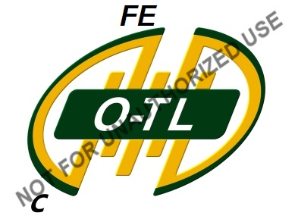

An energy efficiency verification mark indicates that the energy performance of the product has been verified. The qualifying statement for energy efficiency verification is the “FE” indicator in the 11:30 o’clock position of the ‘OTL’ mark. It is not a safety certification mark. It is authorized for use by the certification body and signals the product’s compliance with Canada’s energy efficiency standard (if applicable) and their verification of the energy performance information.

DELIVERABLES TO CLIENT
Once the gas heating product had been verified for energy efficiency, the OTL client is provided a letter report (A-SFFB) and a OTL efficiency verification document (A-SFDS).

The letter report details the energy efficiency data for the gas heating appliance. The reports also elaborates on the product description, differences in models & initiation types, and how each was rated for energy efficiency.

The OTL efficiency verification document approves the client for the use of the OTL energy efficiency mark. Once the client receives this document, they are authorized to use the OTL verification mark on the gas heating appliances by OTL. Regardless of OTLs authorization, the client must still seek final approval from NRCan before implementing the verification mark.

CLIENT SUBMISSIONS TO NRCAN
Once OTL provides the client with the above documentation, the client must submit this information to NRCan. NRCan, based off the above documents and any other supplemental documentation they require, will make the final decision of approval for the use of the verification mark. Once final approval has been established, the client can initiate applying the verification mark.

